Hart Publishing is delighted to give you information about their latest title

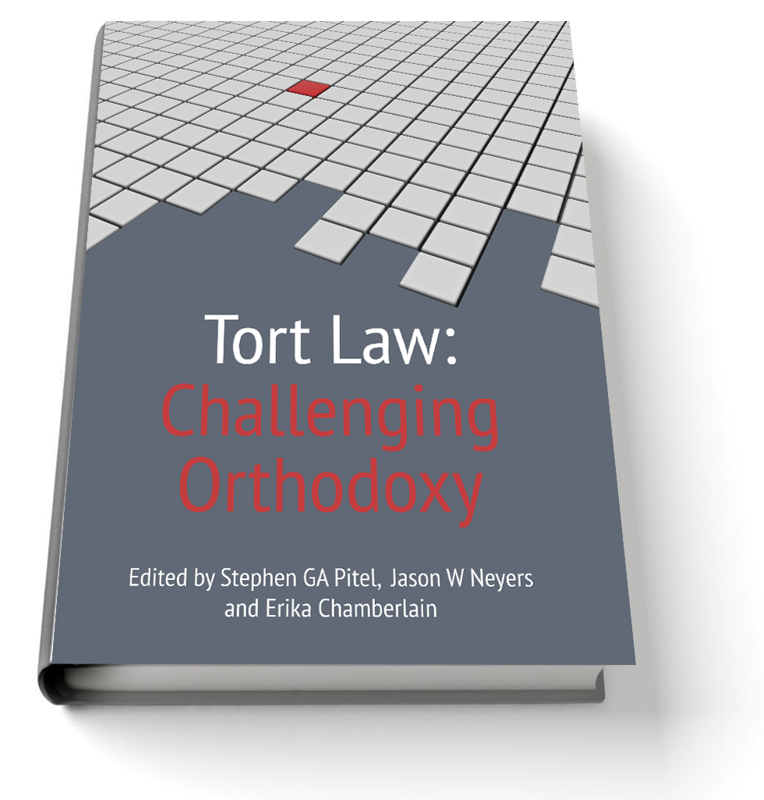
Tort Law: Challenging Orthodoxy
Edited by Stephen GA Pitel,
Jason W Neyers and Erika Chamberlain

In this book leading scholars from the United Kingdom, the United States and Australia challenge established common law rules and suggest new approaches to both old and emerging problems in tort law. Some of the chapters consider broad issues such as the importance of flexibility over certainty in tort law, connections between tort law and human flourishing and the indirect effects of changes in tort law. Other chapters engage more specific topics including the role of vindication in tort law, the relationship between criminal law and tort law, the use of epidemiological evidence in analysing causation, accessory liability in tort law, the role of malice in intentional torts and the role of statutes in tort law. They propose new approaches to contributory negligence, emotional distress, loss of a chance, damages for nuisance, the tort of conspiracy and vicarious liability.

The chapters in this book were originally presented at the Sixth Biennial Conference on the Law of Obligations at Western University in London, Ontario in July 2012. They will be highly useful to lawyers, judges and scholars across the common law
world.

The Editors
Stephen GA Pitel, BA, LLB, LLM, PhD, is a Professor of Law and Goodmans LLP Faculty Fellow in Legal Ethics at Western University.
Jason W Neyers, BA, LLB, MST, is a Professor of Law at Western University.
Erika Chamberlain, LLB, PhD is an Associate Professor of Law and Associate Dean (Academic) at Western University.

Please click here to view the table of contents for this book

Book Details
October 2013 516pp Hbk 9781849464710
RSP: £75 / €97.50
Discount Price: £60 / €78

As a member of the Obligations Discussion Group Hart Publishing is delighted to offer you 20% discount
ORDER ON-LINE
Please click here to order online. When ordering online please type the reference 'ODG' in the voucher code field and click ‘apply’ to receive the discount.

Alternatively, please contact Hart Publishing and quote reference ‘ODG’ to receive the 20% discount.
Hart Publishing Ltd, 16C Worcester Place Oxford OX1 2JW, UK
Tel: +44 (0)1865 517530 Fax: +44 (0)1865 510710
E-mail: mail@hartpub.co.uk; Website: http://www.hartpub.co.uk

